Bug_id_01
Bug Description:
Email field accepts unlimited characters with no length validation, which can cause UI overflow, backend issues, or invalid email format acceptance.


Bug_id_02
Bug Description:
Email field shows both "Enter a valid email" error and a validation tick (success icon) at the same time when entering invalid data like "fff", which is contradictory.
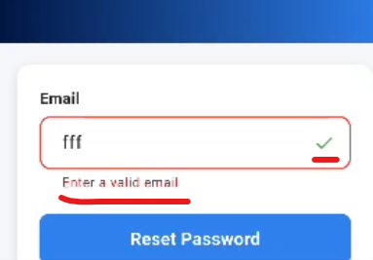

Bug_id_03
Bug Description:
Sign In & Sign Up page shows error "Please enter a valid email address" (lowercase 'e'), while Forgot Password page shows "Enter a valid email" (capital 'E', different wording). This inconsistency in error message text across screens indicates a lack of unified copywriting and reduces UI professionalism.
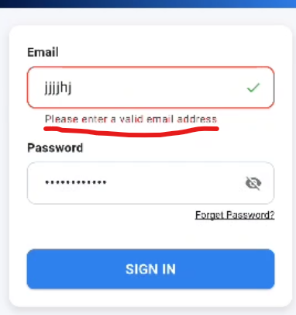
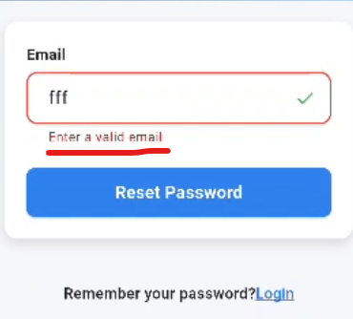

Bug_id_04
Bug Description:
The error message for a missing email field is inconsistent across pages:
- On Sign Up and Sign In pages, it displays "Email is required".
- On the Forgot Password page, it shows "Email required".
This inconsistency in error copy reduces UI cohesion and presents an unprofessional user experience.
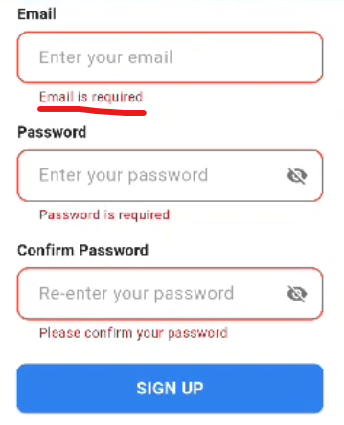
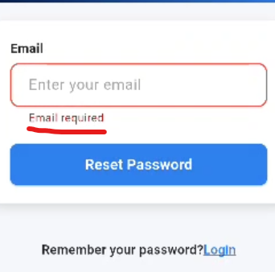

Bug_id_05
Bug Description:
On the Forget password page, entering an invalid email format (e.g., "sh@x.ii") incorrectly shows a validation tick (success icon), misleading the user into thinking the email is valid when it's not. This can cause unnecessary authentication attempts and confusion.

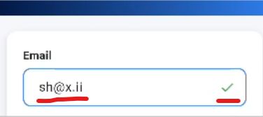

Bug_id_06
Bug Description:
Email field accepts invalid local-part (e.g., "+@gmail.com") and wrongly shows a validation tick, even though email format is incorrect.
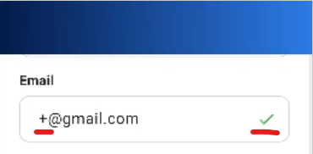

Bug_id_07
Bug Description:
When rotating the phone to horizontal (landscape) mode on the Sign In screen, the UI does not adjust properly — only the logo and heading are visible, while the input fields are squeezed into a small space at the bottom, requiring excessive scrolling and making the form difficult to view or use.


Bug_id_09
Bug Description:
After entering email on the Forgot Password page, the user is directly redirected to the Change Password screen without receiving or entering an OTP/verification link, bypassing essential security verification.


